**PRACTICAL - 2**

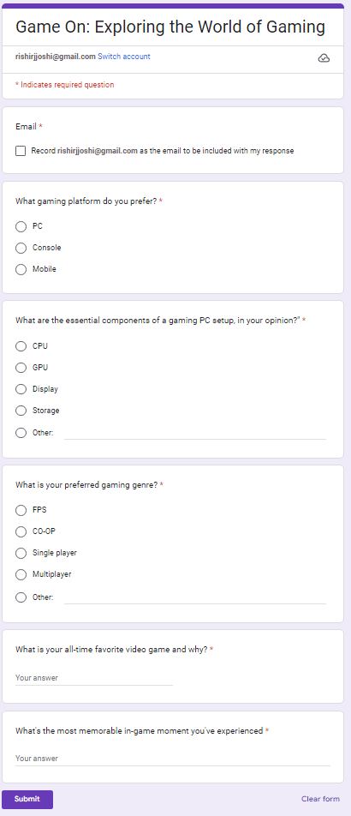

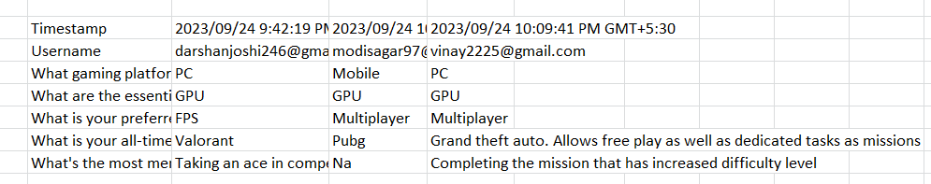

Signature of Faculty: __________ Date: ________